**ASSIGNMENT 1 FRONT SHEET**

|  |  |  |  |
| --- | --- | --- | --- |
| **Qualification** | **BTEC Level 5 HND Diploma in Computing** | | |
| **Unit number and title** | **Unit 3: Professional Practice** | | |
| **Submission date** | 02/12/2021 | **DateReceived1stsubmission** | 02/12/2021 |
| **Re-submissionDate** |  | **DateReceived2ndsubmission** |  |
| **Student Name** | Bùi Hương Linh | **Student ID** | GBH200662 |
| **Class** | GCH1002 | **Assessor name** | Dương Ngọc Sơn |
| **Student declaration**  I certify that the assignment submission is entirely my own work and I fully understand the consequences of plagiarism. I understand that making a false declaration is a form of malpractice. | | | |
|  |  | **Student’s signature** |  |

**Grading grid**

|  |  |  |  |  |  |  |  |  |
| --- | --- | --- | --- | --- | --- | --- | --- | --- |
| P1 | P2 | P3 | P4 | M1 | M2 | M3 | D1 | D2 |
|  |  |  |  |  |  |  |  |  |

|  |  |  |
| --- | --- | --- |
| **❒Summative Feedback:❒ResubmissionFeedback:** | | |
| **Grade:** | **AssessorSignature:** | **Date:** |
| **InternalVerifier’sComments:** | | |
| **Signature&Date:** | | |

Contents

A. Introduction 4

B. Demonstrate, using different communication styles and format, that you can effectively design and deliver a traning event for a given target audience (P1) 4

I. Definition and the importance of communication skill 4

II. Verbal communication 5

III. Non-verbal communication 6

IV. Communication in my group 6

C. Demonstrate that you have used effective time management skills in planning an event (P2) 7

I. Definition and the importance of time management skill 7

II. Planning a training event (group work) 8

D. Demonstrate the use of different problem solving techniques in the design and delivery of an event (P3) 17

I. Definition and the importance of problem solving 17

II. Some techniques and tools for the problem solving 18

E. Demonstrate that critical reasoning has been applied to a given solution (P4) 21

I. Definition and the importance of critical reasoning/school of reasoning (induction/deduction) 21

II. Apply to a given solution 22

F. Performance evaluation 23

I. Tearn member’s roles 23

II. My contribution 23

G. Conclution 24

H. Critical evaluation 24

Bibliography 25

1. Introduction

As you are aware, teamwork is the quickest and smartest way to solve problems. Therefore, students and working people are probably not too unfamiliar with this.

Of course, when I was a high school student, I also practiced. Our team set up a skills workshop for staff members to plan. This workshop aims to provide useful information to help company employees improve their communication skills. The author will provide a brief overview of the workshop, as well as how people are assigned tasks and work styles, in this report. In addition, the author will go over the important lessons learned in the soft skills course.

1. Demonstrate, using different communication styles and format, that you can effectively design and deliver a traning event for a given target audience (P1)
2. Definition and the importance of communication skill

I.1. Definition

Communication is defined as the transfer of information in order to gain a better understanding. Individuals with good communication skills can understand others and be understood by others. Listening, speaking, observing, and empathy are all important aspects in the context of these skills. (Toolshero, 2022)



I.2. The importance of communication skill

Effective communication is essential for both employers and employees. Making a point clearly, for example, can mean the difference between making a deal and passing up a good one. It is also critical that company policy is clearly communicated to customers and employees, and that everyone within the organisation is on the same wavelength. A positive communication climate boosts morale and efficiency in general. To promote the communication climate within organizations, various methods are used, such as the Communication Strategy Framework (CSF), communication plans, dialogue mapping, and the 7Cs, or communication model. (Toolshero, 2022)

1. Verbal communication

Verbal communication is the use of words to convey a message. Some forms of verbal communication are written and oral communication. For exemple: Letters, texting, emails, books, face-to-face conversations, speech, host on a Radio, interviews… (Cloviscenter, 2022)

1. Non-verbal communication

Nonverbal communication is the use of body language to convey a message. For exemple: Handshakes, hugs, smile, sign language, arms crossed over chest (A gesture indicating defensiveness or stress), waving (An indication of "Hello" or "Goodbye" in some cultures)..... (Cloviscenter, 2022)

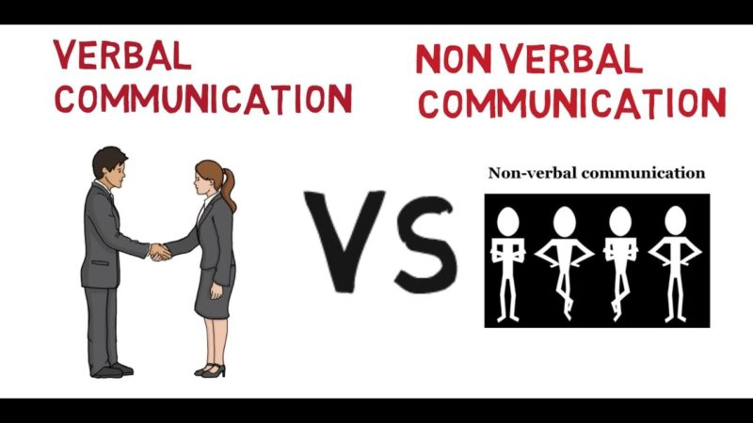

1. Communication in my group

In the author's group, the verbal communication method is most commonly used. Because it helps us exchange conveniently and transmit information faster, besides it also helps us to harmonize at work. When discussing the author will be through group messages. And can not ignore the non-verbal method of communication because it is also quite important and they cannot ignore, the gestures that go with words will make the communication more attractive and attractive. In particular, in the presentation is a must to have a perfect presentation.

1. Demonstrate that you have used effective time management skills in planning an event (P2)
2. Definition and the importance of time management skill

I.1. Definition

Time management is the process of organizing and planning how to divide your time between different activities. Get it right, and you'll end up working smarter, not harder, to get more done in less time – even when time is tight and pressures are high. (Mindtools, 2022)



I.2. The importance of time management skill

There are immense benefits of time management. By understanding the importance of time management in life, we can achieve more in life. Everybody has the same 24 hours in a day. It’s important to learn how to maximize your time so you can be productive at work and life in general. (Harappa, 2020)

By understanding the importance of time management skills, we can transform our lives as well as the society around us.

Let’s take a look at the advantages of time management:

1. Do more in less time
2. Better decision-making
3. Success
4. Superior quality of life
5. Planning a training event (group work)
   1. Name of the Traning program: Skills workshop for staff members planning
   2. Goals of the Traning program:

This workshop aims to provide useful information to help the company’s staff improve their skills in communicating with potential clients and generating more sales.

* 1. Participants: New employees/ Advanced/ Managers?

- New employees of company

- MC: Nguyen The Vinh

- Speaker: Mr. Vuong Huu Hung

Mr. Vuong Huu Hung. With over 15 years of experience working in 10 different countries, he possesses the experience, knowledge, and insights that can greatly help our staff in improving their sales skills

* 1. Time: 2 days. From 7 to 8.(7/2/2022-8/2/2002)
  2. Place: The event will be held at a Novaup meeting hall located at 34T Hoang Dao Thuy. With the capacity of 100 people that it has, a 2-day workshop would be able to allow all employees to participate and gain valuable insight from the experts
  3. Agenda:

AGENDA METTING

Location: Floor 34, building 34T, Hoang Dao Thuy street, Trung Hoa ward, Cau Giay district, Hanoi

Date: 07/02/2022 to 08/02/2022

Agenda day 1: 07/02/2022

|  |  |
| --- | --- |
| 8:30 to 9:00  9:00 to 9:30  9:30 to 11: 30  11:30 t0 13:00  1:00 pm to 4:00 pm  16:00 to 16:20  16:20 to 16:30 | Registration and Reception  Introduction and Opening Ceremonies Speakers: Mr. Vuong Huu Hung MC: Mr. Nguyen The Vinh  Presentation: Sale and Training  Lunch  Continue Presentation: The employees get to directly meet and talk with speaker.  Honoring Ceremony  Evening Reception |

Agenda day 2: 08/02/2022

|  |  |
| --- | --- |
| 8:30 to 9:00  9:00 to 9:30  9:30 to 11: 30  11:30 t0 13:00  1:00 pm to 4:00 pm  16:00 to 16:20  16:20 to 16:30 | Registration and Reception  Introduction and Opening Ceremonies Speakers: Mr. Vuong Huu Hung MC: Mr. Nguyen The Vinh  Presentation: Sale and Training  Lunch  Continue Presentation: The employees get to directly meet and talk with speaker.  Honoring Ceremony  Evening Reception |

* 1. GANTT chart:

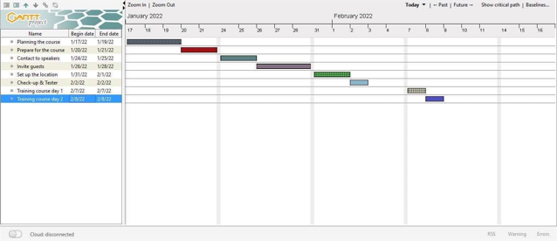

* 1. Estimated Budget:

|  |  |
| --- | --- |
| Venue | 56.000.000 VND |
| Speaker/MC | 10.400.000 VND |
| Equipment | 5.000.000 VND |
| Food/drink | 30.000.000 VND |
| Transport | 2.000.000 VND |
| Entertainment | 7.000.000 VND |
| Decoration | 5.000.000 VND |
| Total | 115.400.000 VND |

* 1. PowerPoint Slides for session

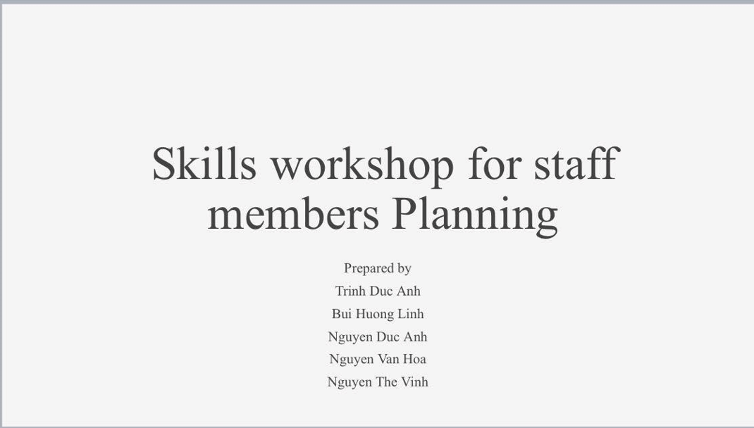

Note: Introduce member in the group and name of planning

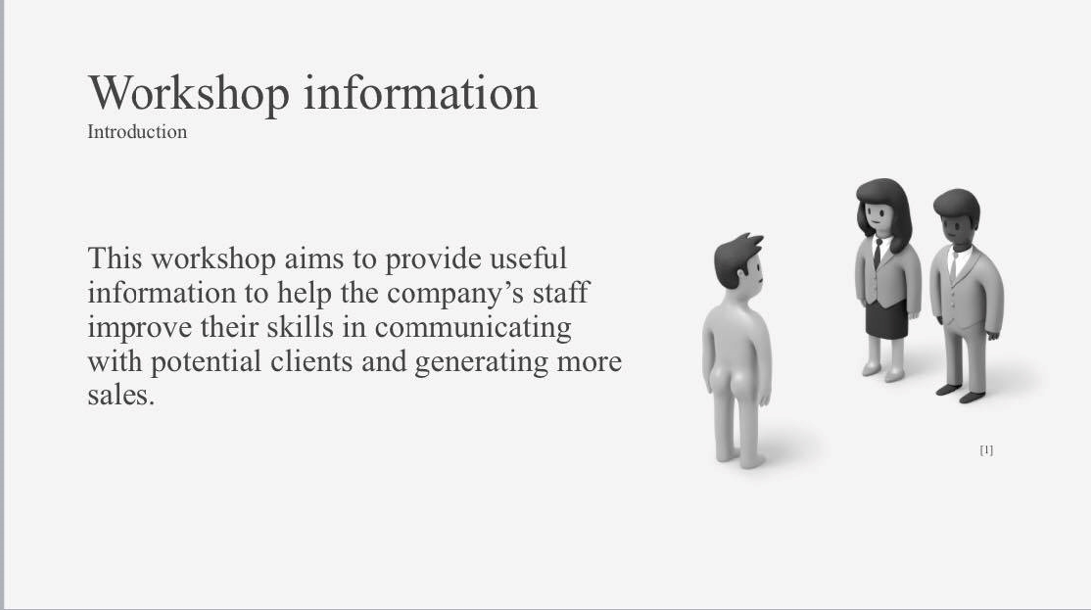

Note: Goal of training program

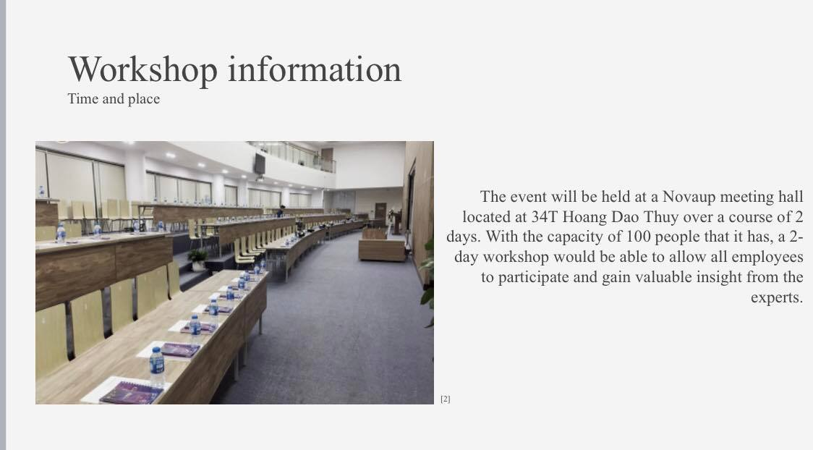

Note: The location where the training starts

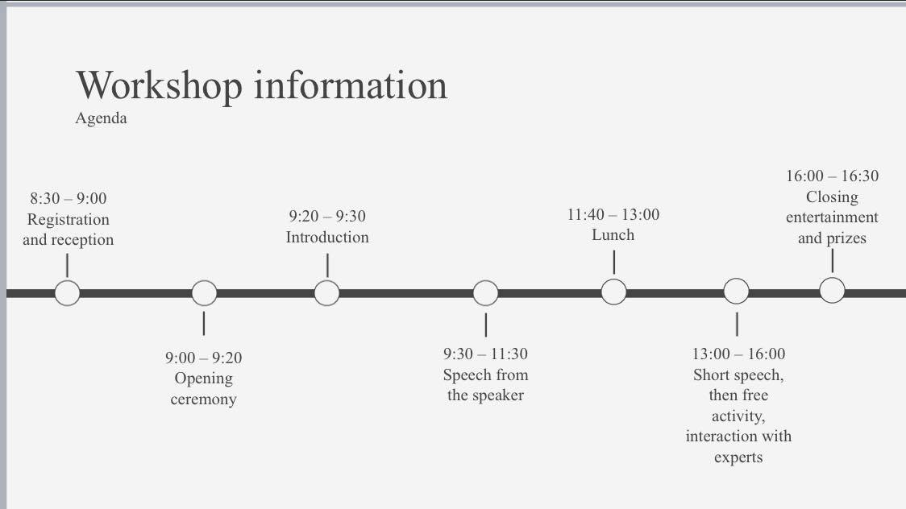

Note: Time agenda

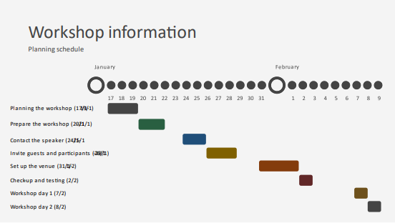

Note: Gantt chart of planning

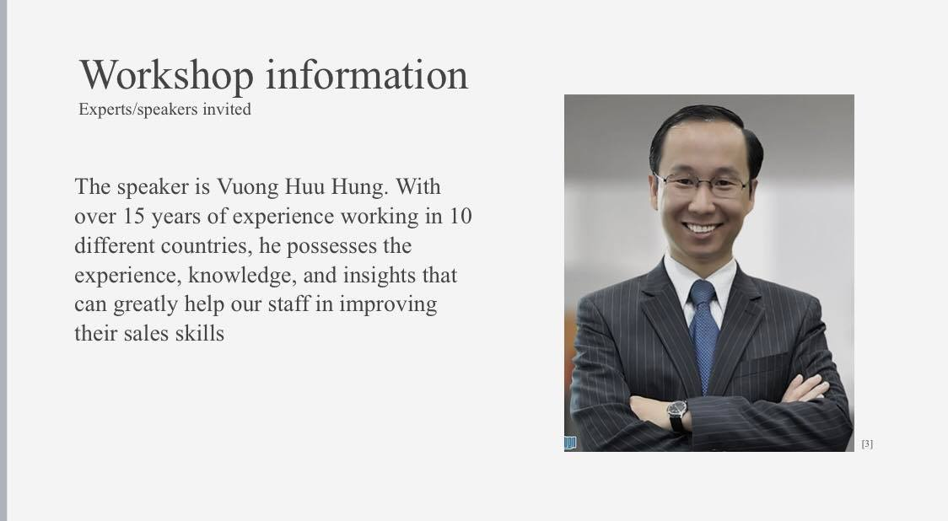

Note: The information of speakers

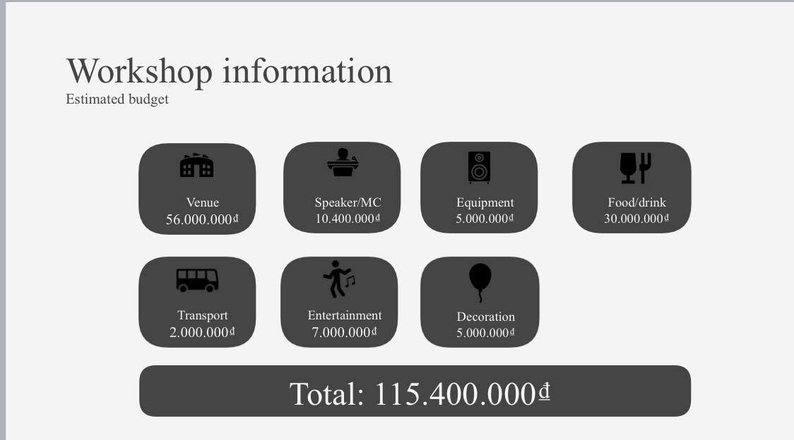

Note: The price of total event

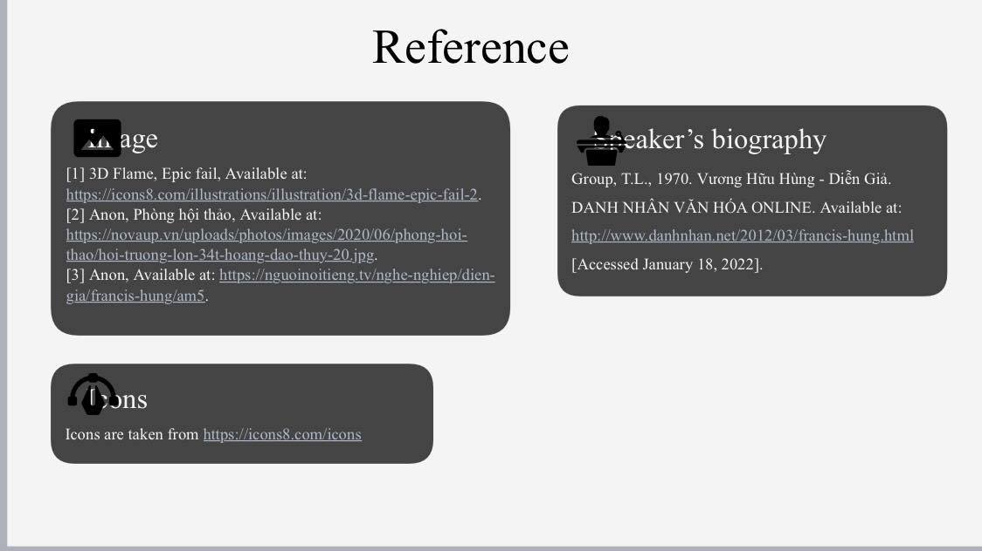

Note: Renference

1. Demonstrate the use of different problem solving techniques in the design and delivery of an event (P3)
2. Definition and the importance of problem solving

I.1. Definition

Problem-solving is the process of observing what is going on in your environment; identifying things that could be changed or improved; diagnosing why the current state is the way it is and the factors and forces that influence it; developing approaches and alternatives to influence change; making decisions about which alternative to select; taking action to implement the changes; and observing impact of those actions in the environment. (WAYNE STOTTLER, 2022)

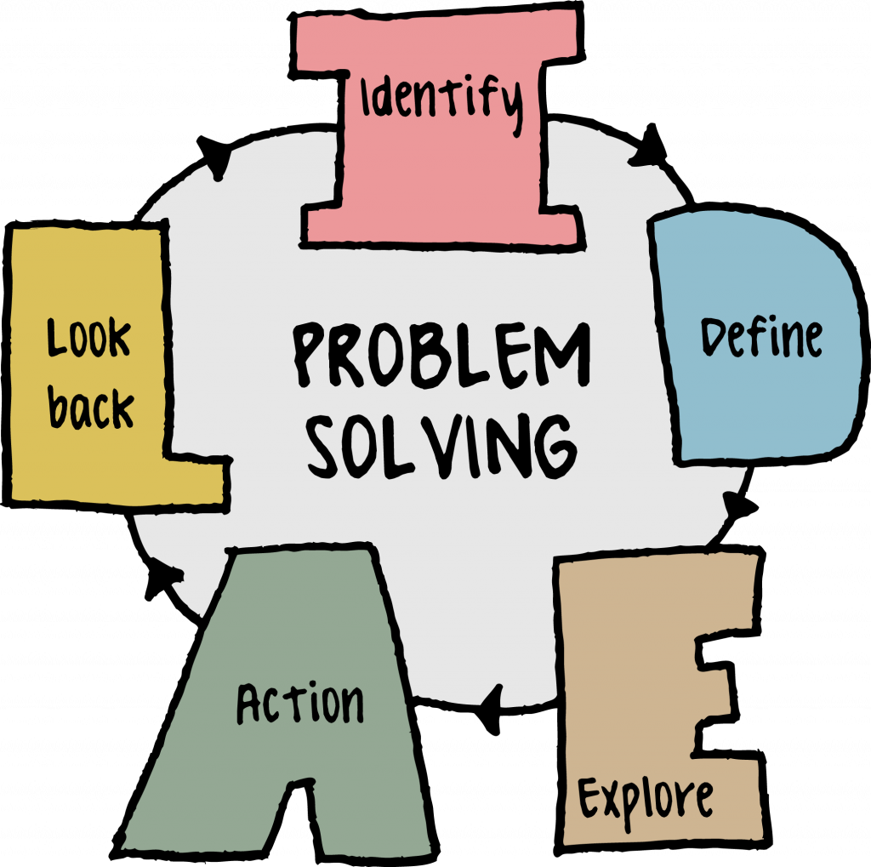

I.2. The importance of problem solving

The importance of problem-solving skills in the workplace can't be overstated. Every business and every job role has its problems. From entry-level hires to senior staffers, every one of your employees will face challenges that don’t can't be answered by a quick Google search.

That's why employers must hire people with problem-solving skills, especially for roles that require dealing with complex business challenges, tight deadlines, and changing variables.

But what are problem-solving skills? And how do they come into play in the workplace? Most importantly, how can you evaluate candidates’ skills before you hire them. (Testgorilla, 2022)

1. Some techniques and tools for the problem solving
2. Flowchart

A flowchart is a **graphical representation of steps of processes in chronological order.** It is considered a generic tool since it has a wide variety of applications and can be used to illustrate several processes. For example, it can describe a project plan, service or an administrative process, or a manufacturing process. (Freeman, 2021)

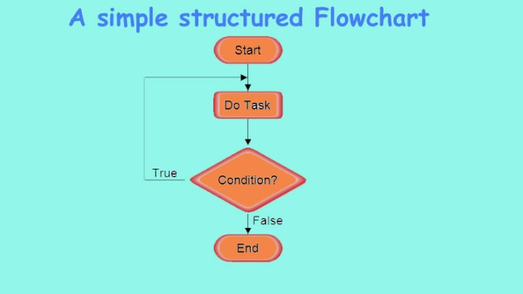

1. Pareto chart

A Pareto Chart is a graph that indicates the frequency of defects, as well as their cumulative impact. Pareto Charts are useful to find the defects to prioritize in order to observe the greatest overall improvement. (Lamarre, 2019)

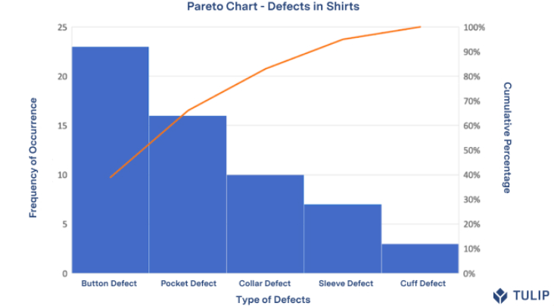

1. Fishbone Diagram

Fishbone diagrams, aka Ishikawa diagrams are used across various industries to analyze causes and their effect. Because of this, they are referred to as cause and effect diagrams too. It provides a systematic approach to deeply analyze a problem when there are many possible causes. This fishbone diagram tutorial will guide you through all the important aspects of fishbone diagrams, including usages, templates and tools to draw fishbone diagrams. (Creately, 2021)

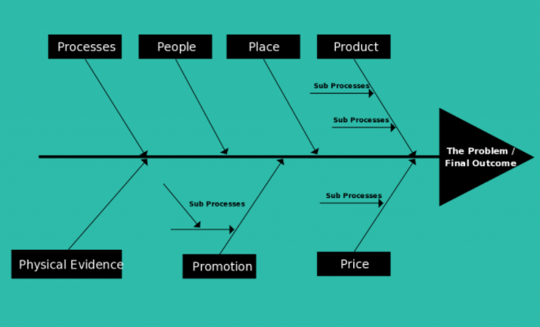

1. Problems and solutions in the training event

|  |  |  |
| --- | --- | --- |
| No | Problems | Solutions |
| 1 | Broken/faulty tool | Check everything before the workshop takes place. |
| 2 | Sudden power outage | Prepare generator |
| 3 | Staff are late | Notify staff to come to the conference 1-2 hours in advance. |

1. Demonstrate that critical reasoning has been applied to a given solution (P4)
2. Definition and the importance of critical reasoning/school of reasoning (induction/deduction)

I.1. Definition

Critical Thinking is the ability to analyze the way you think and present evidence for your ideas, rather than simply accepting your personal reasoning as sufficient proof. You can gain numerous benefits from mastering critical thinking skills, such as better control of your own learning and empathy for other points of view. (Islam, 2015)

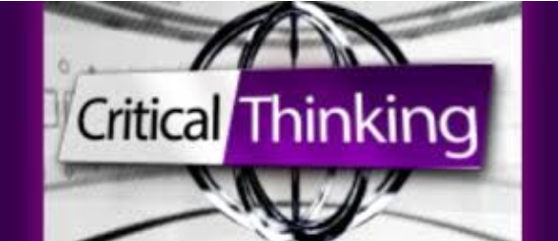

I.2. The importance of critical reasoning

Critical Thinking is very important in the new knowledge economy. The global knowledge economy is driven by information and technology. One has to be able to deal with changes quickly and effectively. The new economy places increasing demands on flexible intellectual skills, and the ability to analyse information and integrate diverse sources of knowledge in solving problems. Good critical thinking promotes such thinking skills, and is very important in the fast-changing workplace…. (Islam, 2015)

1. Apply to a given solution

* Using Element of thoughts/IDEAL model

IDEAL model

|  |  |  |  |  |  |
| --- | --- | --- | --- | --- | --- |
| No | Indentify | Define | Explore alternative solutions | Action | Lookback Evaluation |
| 1 | Some members' English skills are not good | English speaking skills is not good | * Try to use English in your presentation * The members try to learn english * For members to speak in English * Give presentations in English instead of Vietnamese | * Give presentations in English instead of Vietnamese | The present is well commented |
| 2 | Not cooperating on homework | Some members do not cooperate to do homework | * Convince you to do your homework * Give up not doing homework | * Convince you to do your homework | Complete the tasks well |
| 3 | Difficulty finding speakers | Lack of understanding to find the right speaker for the upcoming conference | * Go to google to search for famous authors in the chosen field. * Give up not looking for speakers | * Go to google to search for famous authors in the chosen field. | Well done |

1. Performance evaluation
2. Tearn member’s roles

From the author's perspective, the author's overjoyed and honored to be working with a group of four people with diverse personalities. Thanks to that, the author learns a lot about teamwork styles.

The team was initially quiet, but after being clearly divided into tasks, they became unusually lively, with everyone working hard and eager to contribute ideas and take part. All of this is possible because of Trinh Duc Anh, a friendly, sociable team leader who is also in charge of slide design. Then there's Nguyen The Vinh , who is in charge of finding speakers and, despite his quiet demeanor, has an excellent working style. Furthermore, Nguyen Duc Anh is very good; he is in charge of the cost section, and all revenues and expenditures for the conference are carefully and meticulously calculated. Finally, it is impossible not to mention Nguyen Van Hoa, he is in charge of designing the agenda to create a successful conference.

In short, team 4's working style was excellent for this workshop. They learned about their own and team 4's shortcomings as a result of this workshop. Despite the fact that they are not perfect, they are very happy because they completed the project in the best way possible. With the teachers' valuable feedback, it is certain that the next time they will correct the flaws and improve the project.

1. My contribution

Author in charge of gantt chart for this workshop. The author discussed with the group members about the dates of the workshop. The author has divided the work into specific days to avoid losing time and not remembering what to do.

1. Conclution

In short, every member of the team performed the assigned task perfectly. Especially with the leadership ability of the leader to help team members unite and learn more knowledge. And all members have trust and respect for each other's opinions.

1. Critical evaluation
2. The weakness

* Very little interaction with the group
* Little understanding of slides

1. Strengths

* Good cooperation with other members

1. How to improve your weaknesses

Use google and youtube to research and try to interact as much with team members.

1. The grade that I think I deserve is a pass.

# Bibliography

Cloviscenter. (2022). *Verbal vs. Nonverbal Communication*. Retrieved from https://cloviscenter.libguides.com/: https://cloviscenter.libguides.com/Communication/VerbalVSNonverbal?fbclid=IwAR13fdtlTDnZJB6Q6vnc6RjRa1cCHm9_Z8jg8IuEvFoTas6ibzsnSLChVws

Creately. (2021). *The Ultimate Guide to Fishbone Diagrams (Ishikawa / Cause and Effect)*. Retrieved from https://creately.com: https://creately.com/blog/diagrams/fishbone-diagrams-tutorial/

Freeman, J. (2021). *What is a Flowchart*. Retrieved from https://www.edrawsoft.com: https://www.edrawsoft.com/flowchart-definition.html

Harappa. (2020). *The Benefits Of Time Management*. Retrieved from https://harappa.education: https://harappa.education/harappa-diaries/importance-benefits-and-advantages-of-time-management/

Islam, S. (2015). *What are the Importance and Benefits of "Critical Thinking Skills"?* Retrieved from https://www.linkedin.com: https://www.linkedin.com/pulse/what-importance-benefits-critical-thinking-skills-islam

Lamarre, C. (2019). *What Is A Pareto Chart? Definition & Examples*. Retrieved from https://tulip.co: https://tulip.co/blog/what-is-a-pareto-chart-definition-examples/

Mindtools. (2022). *What Is Time Management?* Retrieved from https://www.mindtools.com: https://www.mindtools.com/pages/article/newHTE_00.htm?fbclid=IwAR22XQeY5bd8BLWRINlRsqWKMmBiVwAIUwqlYHNpq5S2uAyh5csed4DUGsQ

Testgorilla. (2022). *The importance of problem solving skills in the workplace*. Retrieved from https://www.testgorilla.com: https://www.testgorilla.com/blog/importance-of-problem-solving-skills-in-the-workplace/

Toolshero. (2022). *COMMUNICATION SKILLS*. Retrieved from https://www.toolshero.com: https://www.toolshero.com/tag/communication-skills/?fbclid=IwAR2sd9ySDIvixWQHIs9u2vbCZnFRgFc7yBjQAMEAsY9dzBVGnP1Qz34mi9w

WAYNE STOTTLER, K.-T. (2022). *What is problem solving and why is it important*. Retrieved from https://kepner-tregoe.com: https://kepner-tregoe.com/blogs/what-is-problem-solving-and-why-is-it-important/